ACMEISM (АКМЕИЗМ) was a major literary movement of the Russian SILVER AGE. Although difficult to date precisely, scholars generally agree that Acmeism unofficially began with the closing of the major SYMBOLIST publication *VESY* (*THE SCALES*) that coincided with the appearance of the journal *APOLLON* in 1909 and ended with the execution of its nominal founder, the poet, NIKOLAY GUMILYEV (1886-1921) shortly after the Russian Civil War. Conceptualized as a new school of poetry by two disaffected poets from the *Guild of Poets* (*Tsekh Poetov*), Gumilyev and Sergey Gorodetsky, Acmeism became one of the major currents in the post-Symbolist Russian literary avant-garde, competing with the more vociferous Futurism for advancing contemporary Russian poetry into the future. Despite the movement’s brief history and its seemingly conformist alignment with Symbolism, major Acmeist poets such as ANNA AKHMATOVA (1889-1938) and OSIP MANDELSTAM (1891-1938) placed Acmeism firmly on the map of both Russian and European modernism, on a par with Alexander Blok’s Symbolism and Vladimir Mayakovsky’s Futurism.

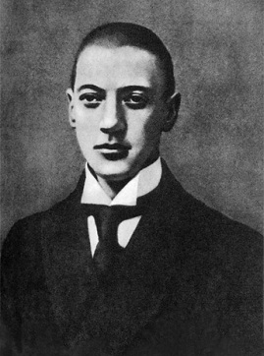 In order to appreciate the critical import and aesthetic significance of Acmeism it is necessary to understand the way it differed from Symbolism and Futurism. In contrast with Symbolism’s valorization of fluidity and Futurism’s experiments with linguistic destruction, Acmeism advocated figural precision and clarity, aiming at compressed and discrete poetic forms. While drawing on multiple elements of classical and cultural mythology, Acmeist verse, nevertheless, is immersed in the world of social and physical realities, plucking its themes from everyday life. Acmeism thus eschews the other-worldly mysticism of Symbolism and the *ad hoc* destructivism of Futurism by harnessing a constructive energy of being-in-the-world.

Photograph of Gumilyev

The Acmeists rejected Symbolism and Futurism because they viewed their poetic projects as unrealizable. Specifically, what the Acmeists found most problematic about both movements were their founding paradoxes: to know the unknowable and creation via destruction. Was it possible, for example, Gumilyev asked, to remember, let alone know, a place where one has never been, and by extension, to create a new literary tradition from nothing? 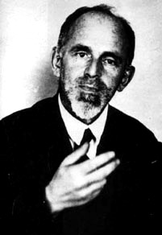 Mandelstam reinforces this concern in his essay “Francois Villon” where he notes that what distinguished the French poet from his contemporaries of the late Middle Ages was his interest in the “timeless” things of everyday life, not the “moon,” the stars, and other things of the cosmos that he could only imagine but never know. Theoretically and practically, the shortcoming of Symbolism and Futurism, for the Acmeists, was that as movements they were held captive by pictures of idealistic goals that, for all intents and purposes, in either the Symbolist *a priori* or Futurist *a posteriori* senses, never did, nor could possibly exist.

The moon and other such neutral “objects” were completely excluded from his poetic usage. On the other hand, he livened up immediately whenever the discussion centered on roast duck or on eternal bliss, objects which never quite lost hope of acquiring.

Mandelstam, “Francois Villon”

Photograph of Mandelstam

How can we remember our previous existences, the time we were in the abyss, with myriads of other possibilities of being, of which we know nothing except that they exist.

Gumilyev, “Acmeism and the Legacy of Symbolism”

Acmeists sought to correct this problem by setting the poet a different task. Instead of envisioning the poet as a trailblazer, seer, discoverer, oracle, or destroyer as the Symbolists and Futurists did, the Acmeists viewed him as a craftsman, builder, laborer, and creator. With this in mind, Acmeists believed that the poet’s task was to strive for the “highest degree” of clarity and precision in his verse as possible. Acmeists thus eschewed manifestos of the type the Symbolists and Futurists authored that elucidated in a language distinct from their art the underlying theory motivating their poetry and prose. For the Acmeists, such a platform was nothing but a repetition of Kantian hierarchy of formal categories that served only to widen the chasm between subject and object. The Acmeist poet’s theory was his practice as evidenced in the creative result derived from the force generated by the momentary contact between the craftsman and his material.

To replace Symbolism there is a new movement, which, whatever it is called – Acmeism (from the work *ακμή* – the highest degree of something, the flower, the time of flowering), or Adamism (a manfully firm, clear view of life).

Gumilyev, “Acmeism and the Legacy of Symbolism”

The Symbolists were poor stay-at-homes; they loved to travel, yet they felt unwell, uncomfortable in the cage of their own organisms or in that universal case which Kant constructed with the aid of his categories.

Mandelstam, “Morning of Acmeism”

A=A: what a magnificent theme for poetry! Symbolism languished and yearned for the law of identity. Acmeism made it its slogan and proposed its adoption instead of the ambiguous *a realibus ad realiora.*

Mandelstam, “Morning of Acmeism”

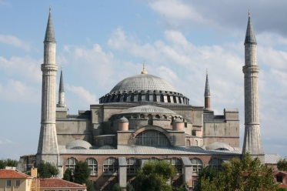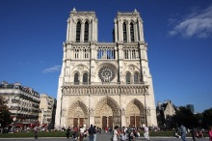The radical extent to which Acmeist poets broke from the theoretical and practical precedents of their Symbolist contemporaries is apparent in both their nuanced notion of gravity and their peculiar definition of Logos. For all the Acmeists, gravity is the fount of the poet-builder’s creativity, the natural force of resistance that holds the keystones of Gothic cathedrals together, making it possible not only for the mason to overcome with his chisel the resistance of every stone, but also the generation of more text via the addition of new pieces. This is evident in the way Mandelstam celebrates the generative dynamism of the Middle Ages in the final poem of *Stone*, “Notre Dame” (1912). Unlike his rendering of the Byzantine Orthodox basilica Hagia Sophia in the collection’s penultimate piece, Mandelstam presents the Catholic cathedral Notre Dame as an open-ended, historical structure built by man in Time from the ground up, against gravity, rather than as a finished, a-historical entity suspended from the eternity of heaven by God.

Picture of Basilica of Hagia Sophia, Istanbul, Turkey

Picture of the Cathedral of Notre Dame, Paris, France

What madman would agree to build if he did not believe in the reality of his material, the resistance of which he knew he must overcome?

Mandelstam, “Morning of Acmeism”

The Acmeists’ textualist sense of gravity motivated their understanding of Logos. The Acmeists did not define the Logos as the definitive center that functioned as the source of everything, be it life, meaning, or non-life. As Mandelstam notes, there is no latent content to the Logos because it describes the “conscious sense” with which the poet approaches and handles the material of his craft, the word. The Logos as such is, as Gumilev suggests in the concluding stanzas of “The Word,” what prevents creation from atrophying into archaic metaphors tied to dead referents. Inspiration for life, not just poetry, as Akhmatova indicates in her biting lyric, “I have no use for odic regiments,” thus comes not from lofty sources eternalized by tradition and convention, but rather from the unexpected, such as the trash heap one inadvertently passes every day on the street.

Where the Roman justice judged a foreign people,  
Stands the basilica: first and joyous,  
Just like Adam, with nerves stretching,  
The vault, a cross of air, flexes its muscles.

But outside a secret plan emerges:  
Here labored the strength of arching stone  
So the freighted mass won't crush the walls,  
And the cocky vault's battering ram is still. Stanzas I & II from “Notre Dame”

We have forgotten that the word alone

Shone radiant over the troubled earth,

And that in the Gospel of St. John

It is written that the word is God.

But we have limited its range

To paltry boundaries of this world,

And like the dead bees in an empty hive

Dead words emit a foul odor.

Final Stanza from Gumilyev’s “The Word”

I have no use for elegiac legions,

Or for the charm of elegiac play

For me, all verse should be off kilter,

Not the usual way.

If only you knew what trash gives rise

To verse, without a tinge of shame,

Like bright dandelions by a fence,

Like burdock and like cocklebur.

Stanzas I & II from Akhmatova’s “I have no use for odic regiments”

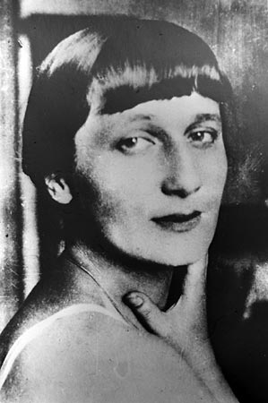

Picture of Anna Akhmatova

Acmeism’s contribution to European Modernism as an aesthetic / critical movement is profound and extends beyond the singular reputations of its leading poets, Mandelstam, Akhmatova, and Gumilyev. Acmeist reconsiderations of the relationship between art and life and, by extension, time and history are decidedly contemporary and germane to recent conceptions of aesthetic production, historiography, and rhetoric. To modern and post-modern critics of the so-called linguistic-turn, Mandelstam’s reading in “The Slate Ode” of the eighteenth-century Russian poet Gavril Derzhavin’s last poem, “The River of Time,” would most certainly resonate loudly: the “here and now” of the present drowns all peoples (poets and kings alike) and all realms (movements, conventions, and empires) in the perpetual flux of the present’s creative abyss.

The current of time’s river

Will carry off all human deeds

And sink into oblivion

All peoples, kingdoms and their kings.

And if something still remains

Through sounds of horn and lyre,

It too will disappear into the maw of time

And not avoid the common fate.

Gavril Derzhavin, “The River of Time”

Steep goatish towns,

A mighty layering of flint,

Yet, there’s another ridge on height –

Sheepish villages and churches!

There a plumb-line preaches,

Time gnaws, water teaches,

And a transparent forest of air

Has had a surfeit of them all.

Like a dead hornet from a hive,

A pied day is swept off with disgrace.

A hawkish night carries a burning chalk

And feeds the slate to erase

A day’s impressions away

From the iconoclastic board,

And shake off transparent visions

Like nestlings from the hand!

Stanzas III & IV from Mandelstam’s “The Slate Ode”

Select Bibliography:

Sam Driver, “Acmeism.” *Slavic and East European Journal* 12 (1968) pp. 141-56. A concise and accurate treatment of the Acmeism; the best place to start for those new to the subject.

Boris Gasparov, “Poetry in the Silver Age,” *The Cambridge Companion to Twentieth Century Russian Literature*. Eds. E. Dobrenko and M. Balina. (Cambridge: 2011) 1-20. A thorough and accessible review and critique of Symbolism, Acmeism, and Futurism; an excellent introduction to the Silver Age.

Graham Roberts, *The Last Soviet Avant-Garde: OBERIU – Fact, Fiction, Metafiction* (Cambridge: 1997). A fine study of this frequently overlooked, yet incredibly creative and important period n twentieth-century Soviet-Russian literature.

D. Mickiewicz, “The Problem of Defining Acmeism” and “The Acmeist Conception of the Poetic Word,” *RLJ*: *Special Supplement,* Spring 1975, pp. 1-20 and 59-76. Excellent pieces that consider the difficulty of defining the movement and its unique apprehension of the relationship between the referent and its representation.

Justin Doherty, *The Acmeist Movement in Russian Literature, Culture and the Word* (Oxford: 1995). Arguably the best English language history Acmeism. Especially strong on the difference between Russian Symbolism and Acmeism.

Omry Ronen, *An Approach to Mandelstam* (Jerusalem: 1983). For more advance readers, Ronen’s reading of Mandelstam’s “Slate Ode” and “January 1, 1924” offers an Acmeist reading in practice while presenting a history of Russian verse the eighteenth to the twentieth-centuries. A must read.

**Matthew McGarry, University of Wisconsin-Madison and Irina Goloubeva, University of Stockholm**

URL citations:

<http://russiapedia.rt.com/prominent-russians/literature/nikolay-gumilev/>

<http://www.angelfire.com/sk/syukhtun/mandelstam.html>

<http://www.slate.com/articles/news_and_politics/clives_lives/2007/02/anna_akhmatova.html>

<http://europeantrips.org/notre-dame-de-paris.html>

<http://annoyzview.wordpress.com/2012/04/02/the-puzzle-surrounding-hagia-sophia/>